**June 2023**

The next Waukegan/North Shore Chapter meeting for 2023 will be on

Friday, September 8, 2023

7:30 pm

*Where:* The State Bank of the Lakes, 50 Commerce Drive, Grayslake, IL (Just west of the old Lake County Fairgrounds).

We kicked off the month of May with an excellent Dust-Off tour. Our first stop was McClure’s Garage in Gurnee, a 100+ year-old business, with displays of historical documents and photos laid out for us to peruse, and commentary from the current proprietor. We moved on from there to Long Grove for a coffee and rest stop, and then to a wonderfully warm and airy outdoor lunch on the patio at the Crossroads Inn in Ingleside. From there the tour concluded at the amazing car and automobilia collection of Jim Manz, housed in a museum-quality building on his beautiful homestead.

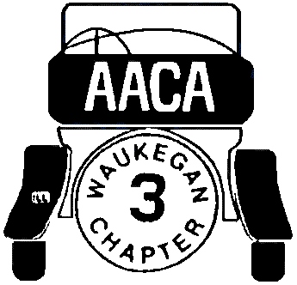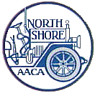

**Officers**

**President:**   
Dan Helgren

**Vice President:**   
 Chris Schurrer

# Secretary &

# Klaxon Editor: Jim Greenlee

**Treasurer:**Don Schreiber

**News Correspondent:**JoAnn Flynn

**Facebook Group:**Waukegan North Shore Chapter Antique Automobile Club of America

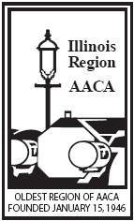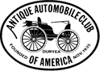

**KLAXON**

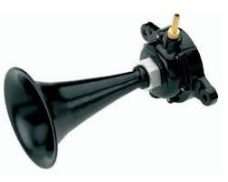

**Monthly Newsletter to the Waukegan-North Shore Chapter**